14-Nov-22 Waste Management
Sent on behalf of Vasu Siva, GP Partner & Clinical Lead for Green Agenda
Dear Colleagues,
Our focus this week is on reducing unnecessary wastage, in particular reuse – stops new items from being made and old items from being wasted. This is one of the ‘Bucket’ list items on the ES Green initiative.
ACTIVITY: Reuse as many items as possible
What is the activity? | - Re-use as many items as possible and put up signs in the practice to encourage staff to think about what they are using & how to reduce waste (conscience prodder)
What are the benefits of the activity?  (GP surgery, staff, patients, community, environment) | - Cost savings  - Reduces wastage  - Sustainable environment
How to carry out the activity?  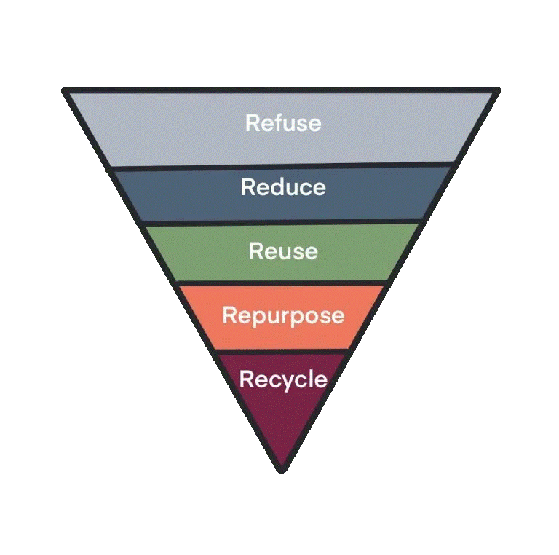 | - Put up signs  - Discuss in staff/practice meetings  - Encourage staff to reflect on what is being used & how to reduce wastage  - Encourage staff to reuse as many items as possible instead of buying new ones (e.g. reusable water bottles, plates & coffee cups; scrap paper & paper clips instead of post it notes; consider adoption of Sharpsmart reusable sharps bins)
How would this be measured? | - Staff feedback  - Practices to review the 6-12 monthly invoices
What are the benefits/award once you have completed the activity? | - GP practices would have completed one of the ‘Bucket list items’ mentioned in the ES 25 Green Initiative  - You would have contributed towards NHSE ambition
How will this be reported? | - Annual submission of the evidence of participation of the Bucket list items mentioned in the Delivery section of ES 25 Green Initiative
Understanding the importance of the '5 R’s: refuse, reduce, reuse, and repurpose should be considered prior to recycling. Incorporate this into your practice’s waste reduction and recycling efforts to minimise landfill waste and reduce carbon emissions.
Helpful Resources:
https://www.greenerpractice.co.uk/information-and-resources/organisational-considerations/reducing-waste-in-health-care/

