WFHP Sustainable Inhaler prescribing guide for adult asthma
Not so good…  Nhjhj  NotN | Hmmm…OK! But how about >>>>>>>>>>>>>>> | Great! Can you breathe in quickly and deeply through your mouth within 2-3 seconds? If yes DPI should be fine
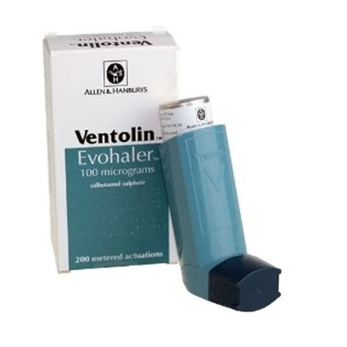 | 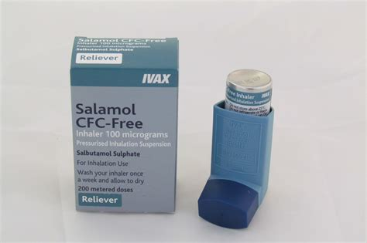 | 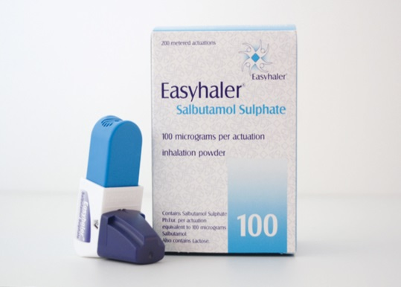  *See notes re SABA DPI use
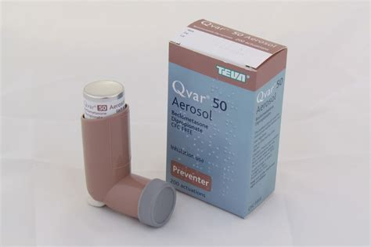  2 puffs BD | 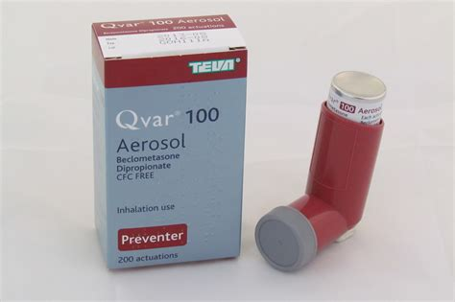  1 puff BD halves propellant output | 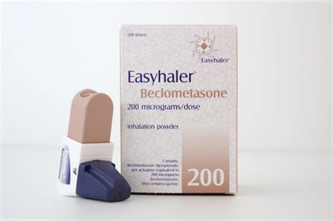  1 puff BD. Interchangeable with budesonide below
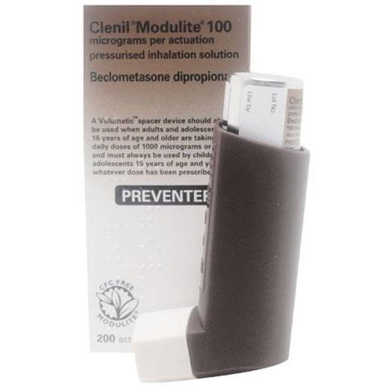  2 p  2 puffs BD | 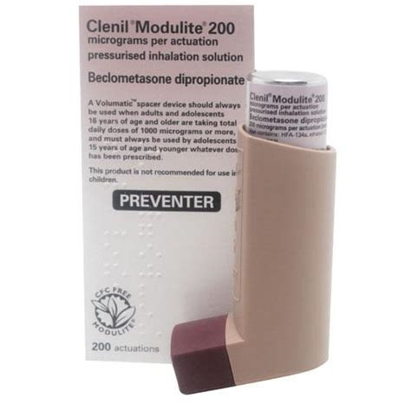  1 puff BD halves propellant output | 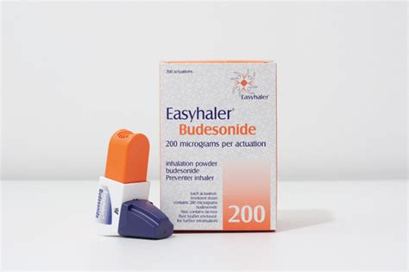  1 puff BD or see above
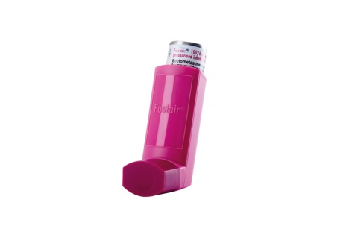  Fostair 100/6 1puff BD | Step 2 inhalers  Fostair 100/6 and Flutiform 50/5 MDI (left) can both be switched to any of the 3 devices to the right:  Fostair 100/6 DPI  Duoresp Spiromax 160/4.5  Fobumix Easyhaler 160/4.5 | 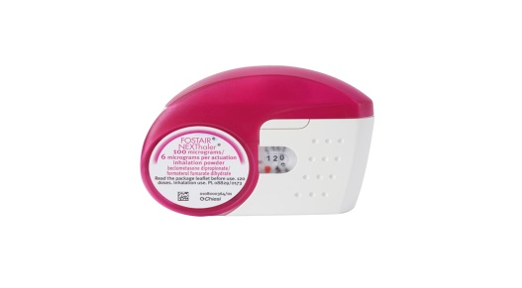  Fostair Nexthaler 100/6 1 puff BD
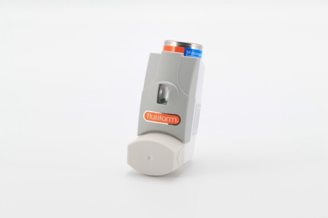  Flutiform 50/5 2 puffs bd  MOST DAMAGING INHALER | >>>>>>>>>>>  >>>>>>>>>>>>>  >>>>>>>>>> | 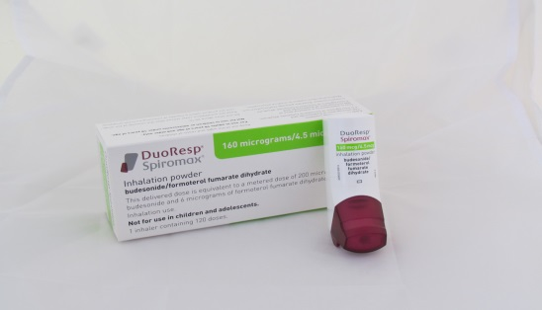  Duoresp Spiromax 160/4.5 1 puff BD  OR 2 puffs OD (compliance benefit)
MART information:  https://www.asthma.org.uk/advice/inhalers-medicines-treatments/inhalers-and-spacers/mart/ | At this step strongly consider prescribing as MART therapy to reduce SABA use and improve asthma control:  Fostair 100/6 1 puff BD AND one additional puff upto 6 times daily (max total 8 puffs daily  Duoresp Spiromax 160/4.5 2puffs OD or 1-2puffs BD and extra doses when needed upto total 8 puffs daily  Fobumix Easyhaler 160/4.5 2puffs OD or 1-2puffs BD and extra doses when needed upto total 8 puffs daily | 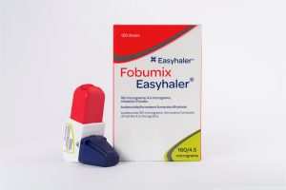  Fobumix Easyhaler 160/4.5 1 puff bd
 | PTO
Fostair 100/6 2 puffs BD  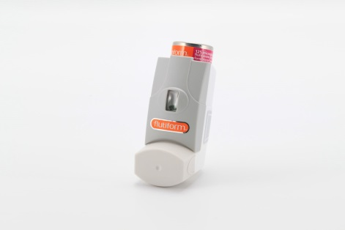  Flutiform 125/5 2 puffs BD  THE MOST DAMAGING INHALER | Step 3 Inhalers  Either inhaler on the left can be switched to any of the four on the right. | Fostair Nexthaler 100/6 2 puffs twice daily (device image above)  OR  Duoresp Spiromax 320/9 1 puff twice daily (device image above)  OR  Fobumix easyhaler 320/9 1 puff twice daily (device image above)  OR  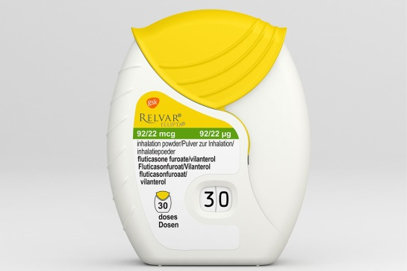  Relvar Ellipta 92/22 1 puff ONCE daily
 | Specialist Therapies  See County asthma guidelines. Caution- consider specialist advice prior to switching inhalers in this category as patients likely to be higher risk. | *Notes re SABA DPI use:  For reliever inhalers where there is concern that the patient may not be able to use a dry powder device during an exacerbation a backup salamol MDI and spacer can be given for emergency use and a dry powder device prescribed for day to day reliever use.  This would apply particularly to patients who have a history of frequent exacerbations or hospital admission.

