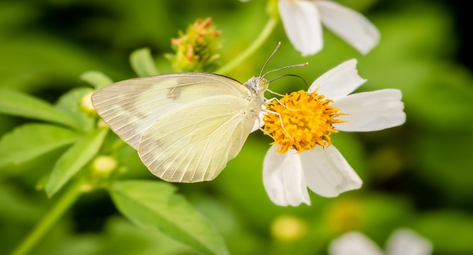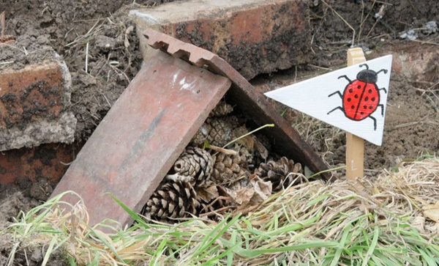
Top 10 tips for boosting biodiversity on GP Estate

Nurture native species: Aim to plant and grow mainly native species of plants, grasses, shrubs and trees. Specifically, those that attract pollinators. Remove non-natives and seek advice on removing invasive species.

- Quit the chemicals: Avoid or reduce the use of pesticides or herbicides. If you must use, use organic ones. Ideally use gentler options such as oil, soap or garlic insecticide sprays.

- Yes, to fruit trees: Always beautiful and they provide food for pollinators, birds, and snacks for humans too.

- Go wild: Grow wild areas and plant wildflowers. Leave grassed areas uncut for as long as possible, don’t start cutting until after mid-April on a 6-week rotation. Love a lawn with Dandelions and Clover.

- Seasonal snacks: Plant species that will provide food sources for as much wildlife as possible across the year. Use Primrose, Rosemary, Hawthorn, Foxglove, Lavender, Catnip, and Ivy for example. Provide birdfeeders and keep them well stocked over autumn and winter.

- Homes for wildlife: Set up Nest boxes and bat boxes. Create bug hotels and hedgehog houses.

- Create a tree base: Grow plants, small shrubs, or herbs at the base of existing trees. Trees like company.

- Create a pile of: Leaves or logs, insects, birds, and small mammals will benefit from the cover and protection they provide.

- Create a water fill up station: If there is space a pond of any size is great or a bird bath is worth investing in too. Harvest rainwater where possible to top up a pond and water the plants.

- Share your knowledge: Let your patients and local community know what you are doing and why. Try and get them involve with design and or maintenance if possible. Include a seat so the green fingered efforts can be admired.
Mike Blades (RTF) NHCT
Claire Thompson GENEE
Dr Georgie Sowman

