Sustainable Quality Improvement (Dr Honey Smith)

Home | Sustainable Quality Improvement (susqi.org) (video)

Principles of Sustainable Health Care
- Disease prevention / health promotion (screening, case finding, lifestyle interventions etc)
- Patient empowerment (eg personalised asthma action plans, patient education and self-management of long term conditions)
- Lean pathways (maximum value for patients whilst reducing waste in time / money / carbon)
- Low carbon alternatives (eg lower carbon inhalers, reusable PPE etc)

The SusQI framework (Centre for Sustainable Healthcare)
Sustainable QI (or SusQI) recognises that there are finite environmental, social and financial resources available to deliver a high standard of patient care. The overall goal of sustainable quality improvement is to maximise sustainable value. This means to deliver the best possible health outcomes with minimum financial and environmental costs, while adding positive social value at every opportunity. As in standard cost-benefit analysis, the concept can be expressed as an equation, where value = outcomes / costs:
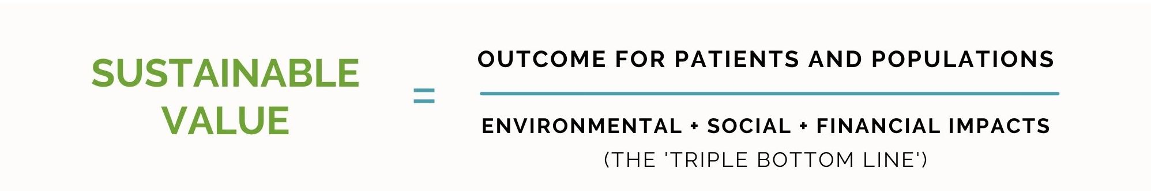
The Sustainability in Quality Improvement framework (SusQI) is an approach to improving healthcare in a holistic way, by assessing quality and value through the lens of a “triple bottom line”. In SusQI, the health outcomes of a service are measured against its environmental, social and economic costs and impacts to determine its “sustainable value”.

Step-by-step guide | Centre for Sustainab (susqi.org)

If you apply the principles of Sustainable Health Care to the issue you want to audit, it is likely that at least one of these principles will have relevance to your project.

Examples
- A project on reviewing the prescription of antidepressants - might look at whether lifestyle interventions / CBT etc were offered firstline, whether alcohol and drug use was addressed, whether a review was done to consider withdrawal of antidepressants after several months of treatment . (Disease prevention, patient empowerment, lean pathways) Environmental, social and financial benefits
- A project on deprescribing of drugs of doubtful longterm value eg quinine, analgesics for chronic pain – might include alternative strategies for managing the condition. (Patient empowerment, health promotion, lean pathways) Environmental, social and financial benefits
- A project on chronic disease management - eg cardiovascular monitoring and endometrial protection for patients with PCOS (Disease prevention, patient empowerment) Environmental social and likely financial benefits of disease prevention and case finding

Other resources
www.greenerpractice.co.uk

Examples of SusQI projects are at Sustainable Quality Improvement — Greener Practice (although sustainable value was not included in the write up of these projects)

