The National Primary Care for Clean Air Project Comms Pack
This communications pack is for health professionals in GP surgeries across England to share information on air pollution with their patients, peers and networks. It contains ready-to use text messages, website and social media content, as well as files you can use in other settings such as electronic screens.

Contents
- Text message
- Website copy
- Social media copy and graphic
- Poster
- Interactive board slides

Text Message
The following is designed to be shared with patients via text message. Change the text if you wish so that it is relevant for the specific patient group and your surgery.
If you suffer from long term lung disease including asthma or COPD, heart and circulatory disease, diabetes, dementia or are pregnant, you may be more vulnerable to the impacts of air pollution.
Find health expert approved guidance with simple steps that you can take to tackle air pollution and protect your health at cleanairhub.org.uk
Website copy
This can be published on your surgery or NHS Network website. Please edit so that it is relevant for the specific patient group and your surgery.
Air pollution impacts us all. It can move from your lungs into your bloodstream and reach many organs in the body.
If you suffer from long term lung disease including asthma or COPD, heart and circulatory disease, diabetes, dementia or are pregnant, you may be more vulnerable to the impacts of air pollution.
Find health expert approved guidance with simple steps that you can take to tackle air pollution and protect your health at cleanairhub.org.uk
Social media copy and graphic
The text and graphics are designed to be published on your surgery or NHS Network social media channels. Please edit so that it is relevant for the specific patient group and your surgery.
There are options for both Twitter and Facebook. The graphics can also be used on screens and interactive boards.

Twitter
Suggested copy | Suggested digital asset (see folder attached)
Air pollution can move from your lungs into your bloodstream and reach many organs in the body. Find health expert approved guidance with simple steps that you can take to tackle #airpollution and protect your health at >> cleanairhub.org.uk | 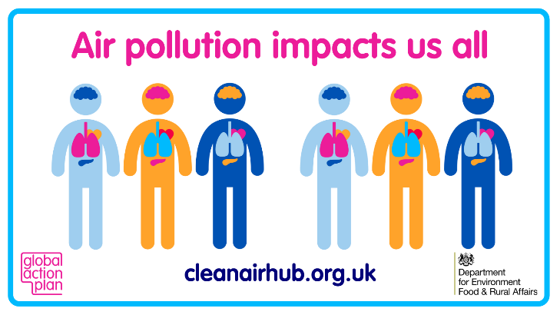

Facebook
Air pollution impacts us all. It can move from your lungs into your bloodstream and reach many organs in the body. Find health expert approved guidance with simple steps that you can take to tackle #airpollution and protect your health at >> cleanairhub.org.uk

Posters
These posters are designed to be printed and pinned around your surgery’s noticeboard, waiting room and toilets.
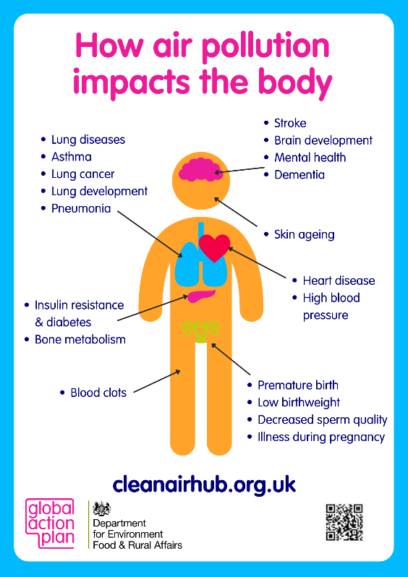
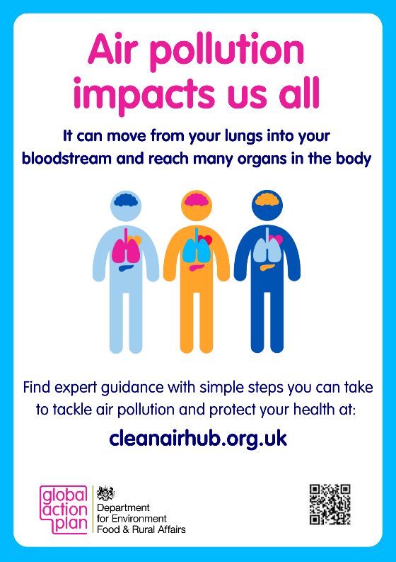

Interactive board
These slides are designed to be printed displayed as a slide show on your surgery’s interactive boards in waiting rooms and hallways.
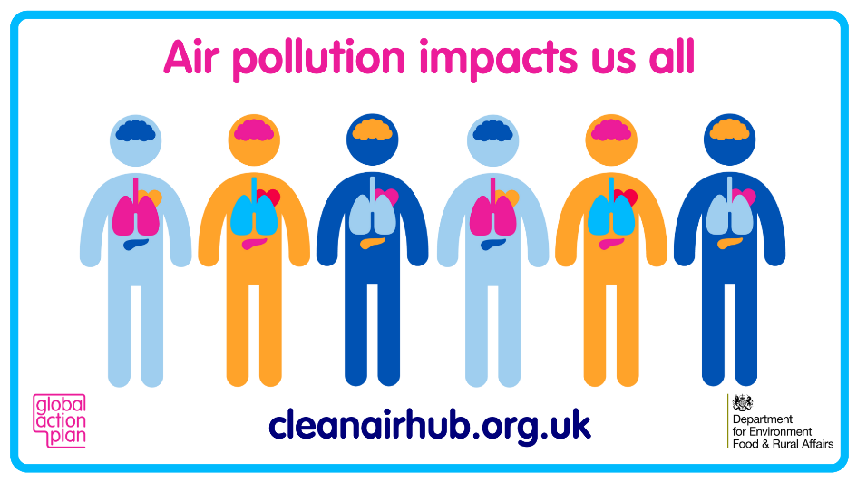

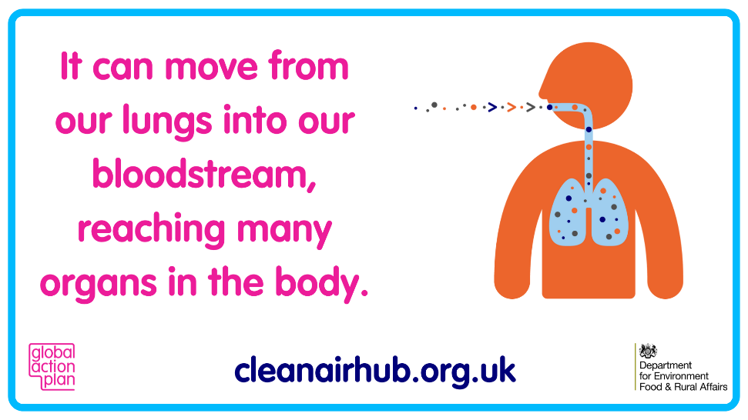

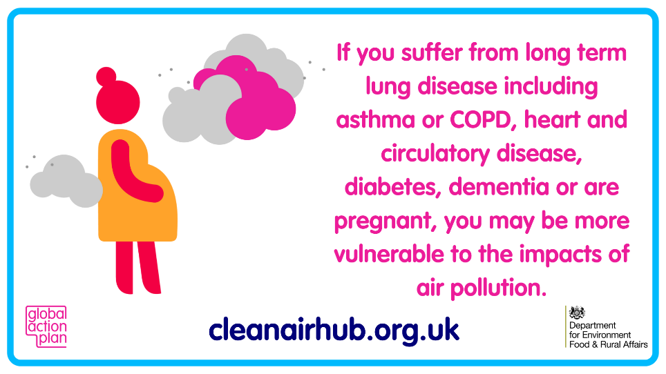

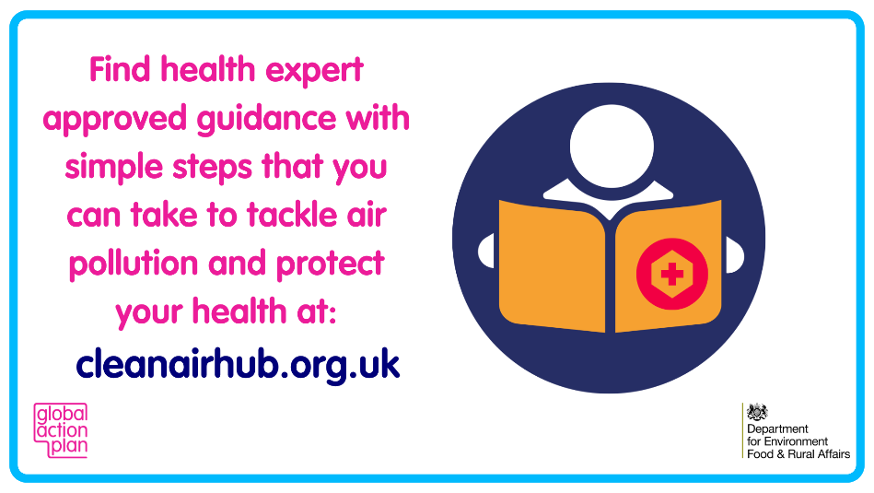

201 Borough High Street, London, SE1 1JA
Telephone 0203 8177 636
Charity registered in England and Wales No. 1026148, in Scotland No. SC041260
Registered company in England and Wales No. 2838296
VAT No. 625 994 009

