Incorporating physical activity into our daily lives is a huge way of improving our own health directly, whilst also improving the health of those around us by reducing air pollution. Join me in congratulating the team at Mill Hill Surgery, Acton who have taken the initiative to lead by example!
Thank you Rosanna Hailstone, for sharing your team’s achievements!
'Currently, all the partners at Mill Hill Surgery travel to work by bike or foot. It has been actively encouraged to travel green and now the trainees are using public transport as well where possible. We have focused on transport as part of our green agenda as we believe in the additional positive health benefits. Getting to Acton can be tricky due to heavy traffic and by cycling, we can guarantee we will get to work on time! Although it can get chilly it is surprising how infrequently we actually get rained on and all in all, we find the cycle home can be quite therapeutic after a heavy day at work! '
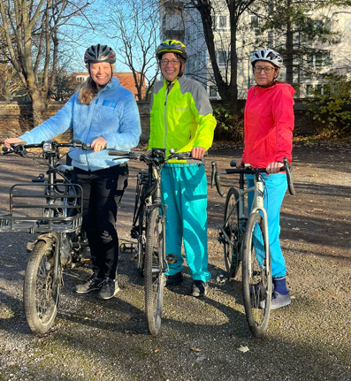
25/11/22

