Cycle to Work schemes for employers: key information.
Methods - there are 3 ways of implementing a Cycle to Work scheme; any employer, of any size, across the public, private and voluntary sectors can run a Cycle to Work scheme. Irrespective of the method you choose, cycling to work requires suitable facilities for the employees. These include safe, accessible parking and changing facilities (shower and changing rooms with a personal locker).
- Salary sacrifice schemes.
  - This is the most implemented method. Employees give up part of their pre-tax salary; this money is used to provide them with a bike and protective equipment.
  - There is a hire agreement between the employee and employer, who has either purchased the equipment or leased it from a third party (such as a retailer or a specialist leasing firm).
  - At the end of the period, which typically lasts 12 months, the employer may give the option to purchase the bike.
- Loan schemes
  - The employer gives the employee a loan to purchase a bike and accessories, which the employee then repays over a set period.
- Pooled schemes - In this case, the company purchases a fleet of bicycles and makes them available on a one-to-one or pool sharing basis.
The owner under the consumer hire agreement may need Financial Conduct Authority (FCA) authorisation. Details on how to apply are here: https://www.fca.org.uk/firms/authorisation
- There is an exemption from needing authorisation where the owner is the employer and the total value of the goods being hired does not exceed £1,000. The agreement must be under a relevant employee benefit scheme. This exemption is provided under the Financial Services and Markets Act 2000 (Exemption) Order 2001 (referred to here as the FSMA Order).
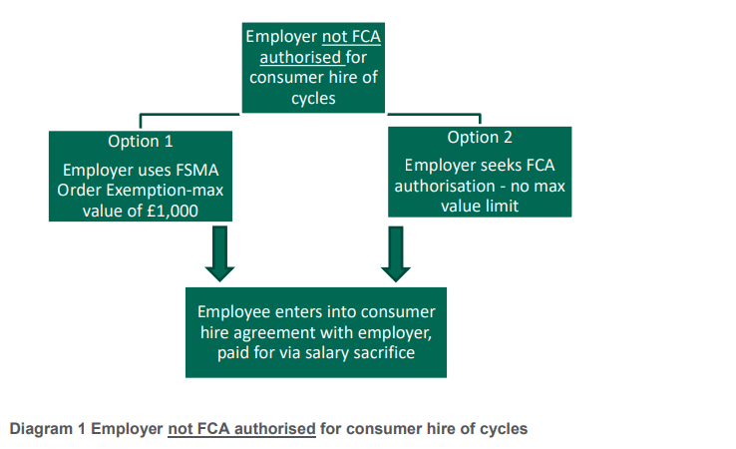
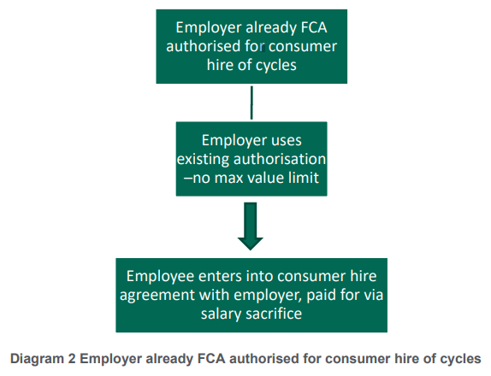
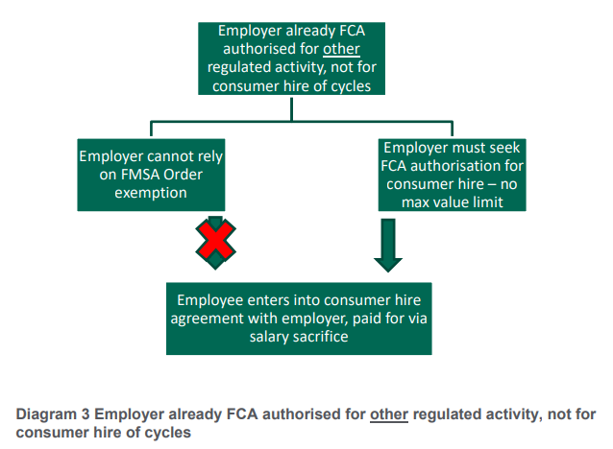

Tax-benefits - if the scheme meets the relevant criteria it can benefit from a tax exemption introduced under Section 244 of the Income Tax (Earnings and Pensions) Act 2003. Since a portion of the salary is foregone, the employee pays less tax and National Insurance Contributions (NICs), and the employer can save on employer NICs at 13.8% and Apprenticeship Levy at 0.5% (where applicable) on the amount sacrificed.
Eligibility - Any employer, of any size, across the public, private and voluntary sectors can run a Cycle to Work scheme. However, the tax and NI benefits apply only to staff who are treated as employees for tax purposes.
Other important rules:
- An employee must not, at any point during the hire period, own the cycle.
- At least 50% of the cycle’s use must be for ‘qualifying journeys’, i.e. commuting to work.
- The offer of the use of hired cycles must be made available across the whole workforce, with no groups of employees being excluded. This does not necessarily have to be through a salary sacrifice arrangement in each case.
You can set up and run your own salary sacrifice scheme, or Cycle to Work scheme providers can run the scheme for you; there are several benefits for the latter option:
- Ensure the scheme is fully compliant with legislation.
- Administer the scheme for you, reducing complexity.
- Advise you on salary sacrifice arrangements.
- Help you promote the scheme to your employees.
Here are the top 4 cycle to work scheme providers and links to their websites – they all have instructions on how to sign up
- Cyclescheme: https://www.cyclescheme.co.uk/employers
- Cycle Solutions: https://www.cyclesolutions.info/
- Evans Cycles: https://www.evanscycles.com/b2b/ride-to-work
- Halfords: https://www.halfords.com/cycling/expert-advice/cycle2work.html
More information is available at:
https://assets.publishing.service.gov.uk/government/uploads/system/uploads/attachment_data/file/845725/cycle-to-work-guidance.pdf - Government guidance.
https://cycletoworkalliance.org.uk – click ‘About us’ then go to the FAQ section.

