Title:
The use of PEST questionnaire to assess for psoriatic arthritis in patients aged 16-60 with psoriasis

Student number:
170188155

Word Count: 2366

Introduction

Psoriatic Arthritis (PsA) is a progressive inflammatory joint disease associated with psoriasis (1). Patients with PsA experience reduced functional capacity, reduced quality of life and increased mortality compared with healthy controls (1). The condition is often undiagnosed as shown by a systematic review and meta-analysis that estimated 15.5% of patients with psoriasis have undiagnosed PsA (2). This has significant consequences as delay of PsA diagnosis can lead to worse physical function and considerably more radiographic damage (3). Since GPs are often the first point of call for psoriasis patients and responsible for annual medication reviews, they have an important role to play in recognising early signs of PsA and referring to a rheumatologist. Consequently, the focus of my audit is to determine whether the PEST questionnaire, designed to identify early PsA, is being asked to patients with psoriasis at Richmond Medical Centre (RMC).

The importance of early detection of PsA is particularly important in tackling health inequalities. Health inequalities are differences in people’s health or life expectancy that are unjust and avoidable (4). Health inequalities are prevalent in Sheffield; the average gap in life expectancy is 10 years for men and 7.5 years for women (5). Not only is life expectancy affected by health inequalities, but also lower socioeconomic groups are more likely to experience long term conditions such as psoriasis (4). A systematic review of the association between socioeconomic status and severity of psoriasis, found that lower income households experienced more severe disease (6). Since RMC is located in the 9th most deprived ward in Sheffield, where 38.5% of adults are economically inactive, it is vital that the practice is acting to remedy this inequality (7) .

Another group of people particularly affected by the underdiagnosis of PsA are women (8). In a study of 197 patients, women were found to have more joint pain, significantly higher disease activity and more functional impairment (8). The study followed patients with early signs suggestive of PsA and followed them up for the next 5 years to determine their disease progression using the CASPAR criteria (classification system for PsA)(8). As well as identifying the increased burden of disease, the study also found that delayed diagnosis of PsA for both men and women resulted in poorer outcomes. Women with polyarticular disease were found to have the worst prognosis, emphasising the need for them to be identified early and treated thoroughly to help reduce this health inequality (8).

The Psoriasis Epidemiology Screening Tool (PEST) was designed to help GPs and dermatologists to recognise the early signs of PsA and know when to refer (9). The questionnaire consists of 5 simple ‘yes/no’ questions and a result of 3 or more should trigger a referral to a rheumatologist. A review of the PEST questionnaire in primary care found that it has a sensitivity of 0.98, a specificity of 0.78 and is the most effective screening tool for PsA (2). This suggests it has good validity and it is simple to use. This is particularly important given the ongoing COVID19 pandemic, which is causing a considerable increase in workload at RMC.

Method

To collect the data for my audit I created and merged two reports on SystemOne. I created the first report by searching for the read code ‘Psoriasis’ and used a function to exclude patients with read code ‘PsA’ and ‘guttate psoriasis’. After discussing with my supervisor, I excluded ‘guttate psoriasis’ as it is an acute condition with only 25% of cases developing into chronic plaque psoriasis. I also modified the search criteria to only include patients between the ages of 16 and 60. The incidence of PsA declines significantly after the age of 60 (1) and I expected patients under 16 to already be under the care of a dermatologist and the PEST tool is not valid for this age group (10).

I used a random number generator to select 40 patients from this list and documented my findings in an excel spreadsheet. Using the PEST questionnaire I came up with the following phrases which I searched for in the ‘tabbed journals’ section of each patient over the past 12 months:

- swollen/swelling/joint/arthritis/nail/hole/pit/toe/finger/heel

If a keyword was identified, I read the relevant documentation to determine whether it satisfied my criteria and recorded it in an excel spreadsheet. During my search I found that three patients had already been diagnosed with PsA which had not been coded or they had been referred for further investigation so I excluded the findings from my results.

Criteria

NICE guidelines recommend that patients with psoriasis should be offered annual assessment for PsA (10). They suggest that a screening tool such as PEST be used to diagnose PsA in a primary care setting (10). I modified the PEST questions slightly for the criteria to allow for questions that may not need to be asked e.g. if patients present with a symptom it is unnecessary to ask whether that symptom has occurred.

Below I have justified the importance of the PEST criteria:

- Has the patient ever had a swollen joint or asked if they have had a swollen joint/or joints in the past?

PsA most typically presents as oligoarticular mild disease (1). Joint pain, stiffness and swelling are the most common symptoms of PsA and are typically caused by bone erosion and inflammation of entheses and synovial sheaths of tendons (11). During a study of the efficacy of the PEST questionnaire in Japan, this question was most commonly answered ‘yes’ in patients with PsA suggesting it is the most important answer to illicit when reviewing patients with psoriasis (12). Additionally, patients who present with 5 or more swollen joints are much more likely to experience disease progression and are at an increased risk of developing erosive disease (1). This highlights the need to detect patients the first time that they present with a swollen joint to improve their outcome and consequent functionability.

Furthermore, research into patients’ ability to accurately self-report joint swelling in a cohort of patients with PsA found that patients’ self evaluation of swollen joints correlated with effusion synovitis found under ultrasound (13). This suggests that patients’ are adept at identifying disease progression in PsA.

- Has the patient ever been asked or told that they have arthritis?

PsA can follow the pattern of other inflammatory joint conditions therefore it may be difficult for the non dermatologist to distinguish PsA from other forms of arthritis (1). It is important to review previous investigations for arthropathy and clarify that patients have not been misdiagnosed.

- Has the patient been asked whether their fingernails or toenails have holes or pits or have they ever presented with these symptoms?

Distinctive nail changes occur in 87% of patients with PsA and approximately 40-45% of people with psoriasis (1). Consequently this question is important in differentiating between psoriasis patients with and without arthritis. Nail changes are also a key distinguishing feature between PsA and other inflammatory joint conditions, as nail changes are only present in PsA (1). The importance of this question is validated by the fact that nail changes are one of the criteria used to formally diagnose PsA in the CASPAR criteria (1).

- Has the patient ever presented with heel pain or have they been asked if they have ever had heel pain?

Heel pain is caused by joint erosion and synovial inflammation due to PsA (8). PsA affects joints in a ray pattern and the heel is often imaged when investigating for presence of PsA (8).

- Has the patient ever presented with a swollen or painful finger or toe for no apparent reason or have they been asked if this has happened to them before?

A completely swollen finger or toe, dactylitis, is a typical feature of PsA (1). The involvement of all joints in the phalange is also a key distinguishing feature from other inflammatory joint diseases such as rheumatoid arthritis (1). Similar to nail changes, it is another diagnostic feature of the CASPAR criteria. Consequently, it is a vital symptom to recognise in patients with psoriasis.

Standards

The standard was agreed after discussion with my GP supervisor. We decided that the questions are quick and easy to ask and should be done at every psoriasis medication review. However, given the disruption that COVID19 has caused and the fact that the practice only introduced a text messaging service within the past 12 months, it is reasonable that asking these questions has not been as easy or even a priority. Given this, we decided that 80% would be a more sensible standard to set.

Results

 | Question 1 | Question 2 | Question 3 | Question 4 | Question 5
Raw results (n) | 7/37 | 3/37 | 1/37 | 0/37 | 2/37
Actual achieved (%) | 19% | 8% | 3% | 0% | 5%
Standard (%) | 80% | 80% | 80% | 80% | 80%

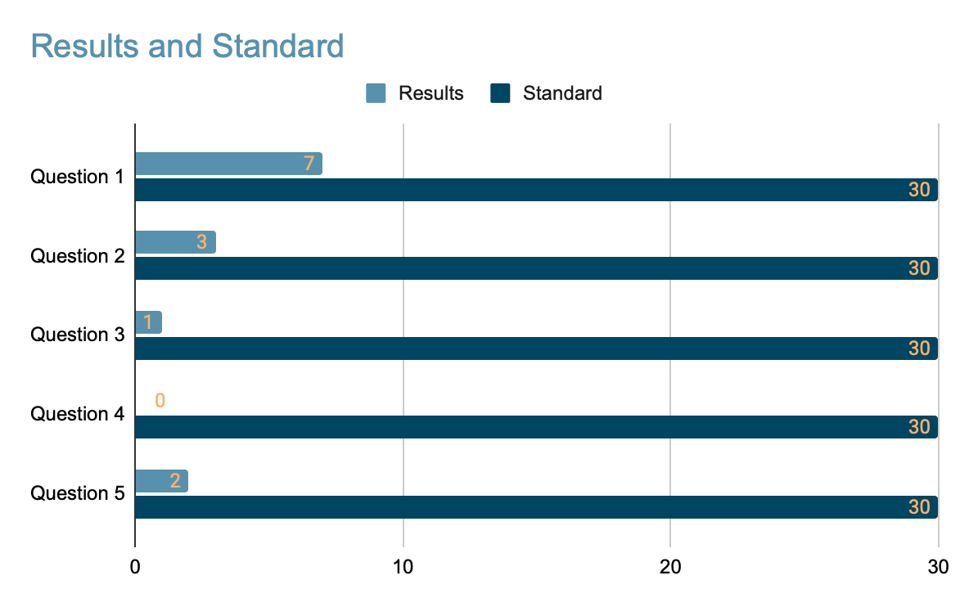

Discussion

The report generated a list of 176 patients, which equates to 2.1% of the practice population. Given that 1.3-2.2% of the UK population is estimated to have psoriasis, I was satisfied that my search was accurate and that psoriasis is not significantly undiagnosed in Richmond practice (2). I also ran a report finding patients aged between 16 and 60 with PsA. The report generated 11 results, representing 0.1% of the total practice and in keeping with the prevalence of 0.1% of the general population (1). However since one third of psoriasis patients are expected to develop PsA, this number is significantly lower than would be expected given the number of psoriasis patients. Assuming all patients with psoriasis also have PsA, RMC only has 6.3% of psoriasis patients diagnosed with PsA compared to the estimated 33.3%. This suggests that PsA in RMC is being significantly undiagnosed.

19% of patients with psoriasis were identified as having been asked if they had a swollen joint or have presented with a swollen joint within the past 12 months. This is far below the agreed standard of 80% and suggests that opportunities to diagnose PsA have been missed. Of the 7 patients who were identified in this question, 5 of these had presented with swollen joints. As early onset PsA most commonly presents with swollen joints, this audit has identified that there may already be patients with undiagnosed PsA. It also demonstrates that patients are being relied upon to attend with symptoms, rather than doctors actively screening them.

8% of patients had been asked whether they had arthritis or told that they had in the past 12 months. As this is a question that is easily answered using the search function on SystemOne, it is more understandable that patients have not been asked. However, it is still important to include in the questionnaire particularly given the difficulty in differentiating from other inflammatory arthritis conditions.

Only 3% (n=1) patients were asked if they had holes or pits in their nails or had attended with these symptoms in the past 12 months. This is particularly concerning given that nail changes occur in 87% of patients with PsA.

No patients were identified as having heel pain or attended with heel pain in the past 12 months. Given that this is one of the least important of the questions, it is arguable that this result has less of a negative impact. Nevertheless, it is important that all five questions are asked together.

Only 5% of patients were asked if they had experienced or had presented with a completely swollen finger or toe in the past 12 months. As this is a key diagnostic feature it is possible that many PsA diagnoses have been missed by the omission of this question during psoriasis reviews.

Clearly, the practice is a long way off the standards that we would expect. However, these results were not surprising as my supervisor advised me that many doctors have not heard of PEST or do not see many patients with psoriasis. Similarly, it is possible that PsA is undiagnosed at RMC as PsA can often be mild in onset meaning symptoms are not significant enough to cause the patient to attend. Finally, an important limitation of the PEST questionnaire is that it does not include axial disease of PsA, with 60% of axial manifestations being missed (9). Doctors must be vigilant to consider this when faced with a borderline PEST result.

Recommendations

To determine which recommendations would be most appropriate and feasible for the practice I presented my findings during a practice meeting. The results were well received and the practice was keen to improve. Out of the options I suggested, they decided to send an annual text message to patients with a short explanation and PEST questionnaire. The text message will be sent via AccuRx to patients with psoriasis aged 16-60, asking patients who score 3 or more to book themselves an appointment with the GP. This solution ensures that NICE guidelines are met, patients with psoriasis are adequately cared for, and does not add too much workload to the practice.

I also made sure to emphasise the particular importance of asking about dactylitis, nail changes and swollen joints for reasons outlined in my ‘discussion’ section. The majority of doctors at the meeting were not aware of the importance of these questions so hopefully they will now be more vigilant in the future.

Sustainability Impact

Identifying psoriatic disease early has obvious health benefits, but it also provides financial, social and environmental benefits. Early diagnosis means that patients experience less loss of function (8). This means that they are less likely to need time off work, resulting in less financial loss. It also means that they are more likely to continue with their hobbies that make them happy and connected within their community e.g. gardening, sport (14). By reducing the severity of disease, early diagnosis also minimises the need for more medical intervention. Given the high carbon impact of the NHS, any reduction in need for healthcare will result in a beneficial impact environmentally (14). Finally, by encouraging patients to fill out the PEST questionnaire themselves and book their own appointments, this empowers patients to manage their own healthcare which is a key principle of sustainable healthcare (14).

References

1. Gladman DD, Antoni C, Mease P, Clegg DO, Nash P. Psoriatic arthritis: epidemiology, clinical features, course, and outcome. Ann Rheum Dis. 2005 Mar;64:ii14.
2. Iragorri N, Hazlewood G, Manns B, Danthurebandara V, Spackman E. Psoriatic arthritis screening: a systematic review and meta-analysis. Rheumatol Oxf Engl. 2019 Apr 1;58(4):692–707.
3. Haroon M, Gallagher P, FitzGerald O. Diagnostic delay of more than 6 months contributes to poor radiographic and functional outcome in psoriatic arthritis. Ann Rheum Dis. 2015 Jun 1;74(6):1045–50.
4. The Kings Fund. What are health inequalities? [Internet]. The King’s Fund. 2020 [cited 2022 Mar 9]. Available from: https://www.kingsfund.org.uk/publications/what-are-health-inequalities
5. Cosgrove S. Why Sheffield is investing public health cash in parks: Council programme targetting areas of the city with the greatest health inequalities. Hortic Week. 2019 Apr 1;15–15.
6. Hiranput S. P51: Socioeconomic factors influence severity rather than incidence of dermatoses. Br J Dermatol. 2021;185(S1):49–49.
7. Sheffield City Council. Richmond Ward Demographics [Internet]. 2017 [cited 2022 Mar 9]. Available from: https://www.sheffield.gov.uk/content/dam/sheffield/docs/your-city-council/facts-figures/ward-profiles/Richmond.pdf
8. Theander E, Husmark T, Alenius G-M, Larsson PT, Teleman A, Geijer M, et al. Early psoriatic arthritis: short symptom duration, male gender and preserved physical functioning at presentation predict favourable outcome at 5-year follow-up. Results from the Swedish Early Psoriatic Arthritis Register (SwePsA). Ann Rheum Dis. 2014 Feb 1;73(2):407–13.
9. Karreman MC, Weel AEAM, van der Ven M, Vis M, Tchetverikov I, Nijsten TEC, et al. Performance of screening tools for psoriatic arthritis: a cross-sectional study in primary care. Rheumatology. 2017 Apr 1;56(4):597–602.
10. NICE. Quality statement 5: Assessing for psoriatic arthritis | Psoriasis | Quality standards | NICE [Internet]. NICE; 2013 [cited 2022 Mar 9]. Available from: https://www.nice.org.uk/guidance/qs40/chapter/quality-statement-5-assessing-for-psoriatic-arthritis
11. Gisondi P, Tinazzi I, Del Giglio M, Girolomoni G. The Diagnostic and Therapeutic Challenge of Early Psoriatic Arthritis. Dermatology. 2010 Aug;221:6–14.
12. Setoyama A, Sawada Y, Saito-Sasaki N, Ohmori S, Omoto D, Yamamoto K, et al. Psoriasis epidemiology screening tool (PEST) is useful for the detection of psoriatic arthritis in the Japanese population. Sci Rep. 2021 Aug 9;11(1):16146.
13. Szentpetery A, Haroon M, O’Flynn E, Gallagher P, Alraqi S, FitzGerald O. SAT0380 Do Patients Know Best? Reliability of Electronic Patient Self-Evaluation of Swollen and Tender Joints in Psoriatic Arthritis: A Comparison Study with B-Mode Ultrasonography, Physician and Nurse Assessments. Ann Rheum Dis. 2014 Jun;73:731.
14. Mortimer F, Isherwood J, Wilkinson A, Vaux E. Sustainability in quality improvement: redefining value. Future Healthc J. 2018 Jun;5(2):88–93.

